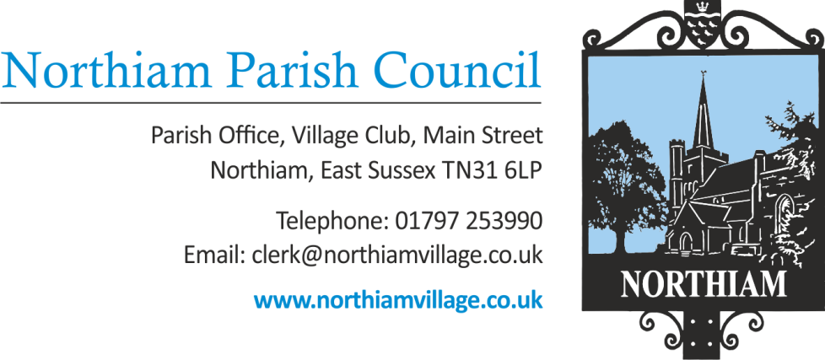

Ordinary General Meeting of the Parish Council to be held in the Village Hall, Northiam at 7.00pm, Thursday 11 August 2022

Members of the Public and Press are welcome and encouraged to attend.
Due to the adoption of new Standing Orders there will be an opportunity for members of the public to give their opinion or view once in relation to an item on the agenda.
AGENDA

SIGNED: Nicola Ideson, Parish Clerk Date: 4th July 2022
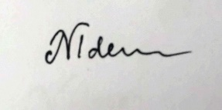
-------------------------------------------------------------------------------------------------------------------------------

- APOLOGIES FOR ABSENCE:

- PUBLIC QUESTIONS (Maximum of 15 minutes)

- DECLARATIONS OF INTEREST AND INSTANCES OF LOBBYING
To receive any declaration by members of personal interests in matters on the agenda, the nature of the interest and whether the member regards the interest as personal, pecuniary or prejudicial under the Code of Members Conduct.

An opportunity for Councillors to declare if they have been approached by a member of the public or another Councillor and asked to discuss any items on the agenda prior to the meeting.

- MINUTES OF THE PREVIOUS MEETING
To approve and sign the minutes of the Full Council meeting held on 14th July 2022 (appendix 1)
- MATTERS ARISING FROM THE MINUTES
- INSTALLATION OF NEW SLIDE
To sign off the Practical Completion Certificate received from the contractors to confirm that the works were satisfactory.

- FINANCES
- To receive & approve the payment report for July 2022 (appendix 4)
- To receive the most recent bank reconciliation and financial report (appendix 5)
- To approve the time-sheet of the Clerk for the period 11/07/22-05/08/22
- To approve the time-sheet of the assistant Clerk for the period 05/06/22-05/08/22
- To note the expenditure of £100 + VAT for a survey assessing the damp problem in bungalow No 2.
- To consider a grant request from the library towards the creation of a new meeting room at the village hall.
- ITEMS CARRIED FORWARD FROM LAST MEETING
- To approve the Asset Register of Council Property.
- To review, approve & adopt Financial Regulations.

- INSURANCE COVER
For decision - to increase the fidelity cover and add loss of receivable rent cover.
- SEWER QUOTES – THE PADDOCK
For decision – To consider 3 quotes obtained for a sewer inspection survey. To be funded by the developer

- COUNCILLOR TRAINING
New Councillor and refresher training has been found by the Clerk.

- TREE SURVEY
Councillors are asked to volunteer to complete the annual Tree Survey.

- WATER SUPPLY FOR BUNGALOWS
Water supply issues stemming from possible lack of pressure due to the recent dry spell

- SFF COMMITTEE MEETING on 28th July – A report

- CCTV SFF
To consider 3 quotes for CCTV to be installed at SFF.

- STABLES LEASE
For decision – proposal to approve the amended Stables Lease and Side Letter

- BURIAL GROUND SURVEY
Proposal from the CIC for the approval of an initial burial ground survey, to be funded from S106 monies

- REPORTS BY COUNTY & DISTRICT COUNCILLORS
- District Councillor Martin Mooney (Appendix 2)
- District Councillor Tony Ganly
- County Councillor Paul Redstone (Appendix 3)

- VILLAGE MATTERS
- Correspondence
- Councillors’ Reports

- PLANNING:
New Applications/Amendments to current applications:
- RR/2022/1704/P NORTHIAM
Grain Store Building, Rye Road, Northiam TN31 6NJ
Conversion of warehouse (former grain store) to self-contained dwelling.

- RR/2022/350/P).RR/2022/1778/P NORTHIAM
Valencia, Station Road, Northiam TN31 6QL
Erection of two detached dwellings with detached garages served by an existing access road.

- RR/2022/1633/P
Three Candles, Station Road, Northiam TN31 6QL
Demolish existing single storey dwelling and erect two single storey dwellings served by existing and proposed access (revised proposal to that permitted by

All appeals, enforcements and decision notices have been previously circulated to Councillors.

