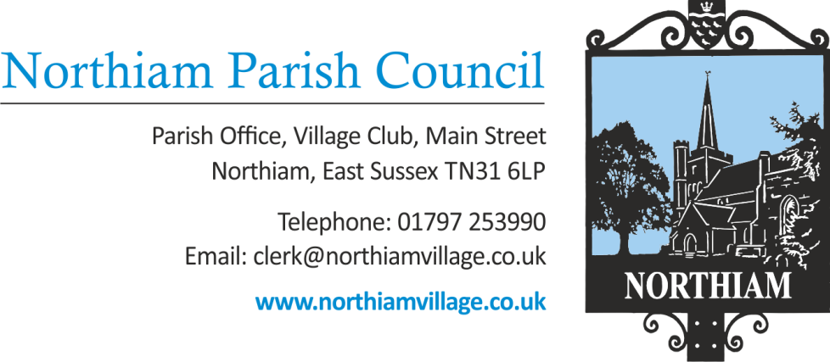

Meeting of the Parish Council to be held in the Village Hall, Northiam at 7.00pm, Thursday 25th August 2022

Members of the Public and Press are welcome and encouraged to attend.
Due to the adoption of new Standing Orders there will be an opportunity for members of the public to give their opinion or view once in relation to an item on the agenda.

AGENDA

SIGNED: Nicola Ideson, Parish Clerk Date: 18th Aug 2022
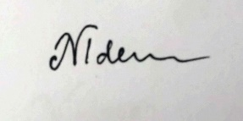
-------------------------------------------------------------------------------------------------------------------------------

- RECORDINGS

- APOLOGIES FOR ABSENCE:

- ELECTION OF NEW CHAIRMAN

- PUBLIC QUESTIONS (Maximum of 15 minutes)

- DECLARATIONS OF INTEREST AND INSTANCES OF LOBBYING
To receive any declaration by members of personal interests in matters on the agenda, the nature of the interest and whether the member regards the interest as personal, pecuniary or prejudicial under the Code of Members Conduct.

An opportunity for Councillors to declare if they have been approached by a member of the public or another Councillor and asked to discuss any items on the agenda prior to the meeting.

- RIGHT TO REPLY FROM CLLR DALLIMORE

- COST ESTIMATE FOR LEGAL ADVICE

- AIRCONDITIONING QUOTES FOR BUNGALOW NO2

- COUNCILLOR VACANCY
Opportunity for members of the public to nominate themselves for Councillor

