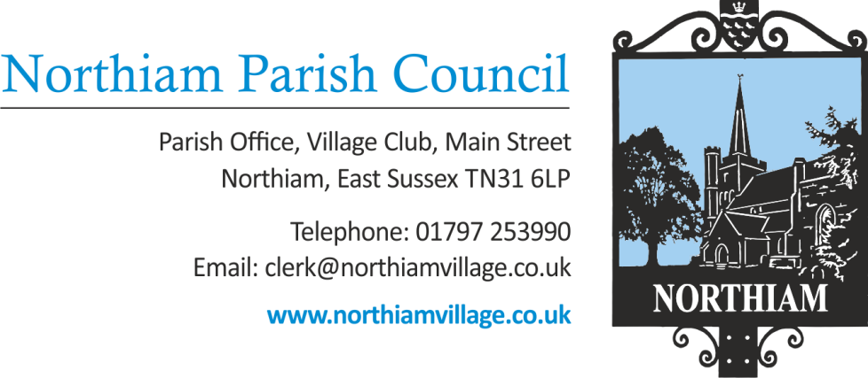

Meeting of the Parish Council to be held in the Village Hall, Northiam at 7.00pm, Thursday 13th October 2022

Members of the Public and Press are welcome and encouraged to attend.
Due to the adoption of new Standing Orders there will be an opportunity for members of the public to give their opinion or view once in relation to an item on the agenda.
AGENDA

SIGNED: Nicola Ideson, Parish Clerk Date: 4th Oct 2022
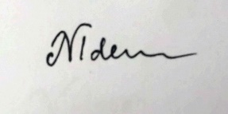
-------------------------------------------------------------------------------------------------------------------------------

- APOLOGIES FOR ABSENCE:

- PUBLIC QUESTIONS (Maximum of 15 minutes)

- DECLARATIONS OF INTEREST AND INSTANCES OF LOBBYING
To receive any declaration by members of personal interests in matters on the agenda, the nature of the interest and whether the member regards the interest as personal, pecuniary or prejudicial under the Code of Members Conduct.

An opportunity for Councillors to declare if they have been approached by a member of the public or another Councillor and asked to discuss any items on the agenda prior to the meeting.

- MINUTES OF THE PREVIOUS MEETING
To approve and sign the minutes and confidential report of the Full Council meeting held on 11th August and the minutes of the Extraordinary meeting held on the 1st September 2022
- MATTERS ARISING FROM THE MINUTES
- INDEPENDENT INSPECTION OF NEW SLIDE
The Clerk has sourced another playground equipment supplier that is willing to give a free expert opinion,

- FINANCES
- To receive & approve the payment report for September 2022
- To receive the most recent bank reconciliation and financial report
- To approve the time-sheet of the Clerk for the period 02/09/22-07/10/22
- To approve the time-sheet of the assistant Clerk for the period 02/09/22 – 07/10/22

- COUNCILLOR VACANCY – FOLLOWING THE RESIGNATION OF SUE SCHLESINGER

- COUNCILLOR VACANCY – FOLLOWING THE RESIGNATION OF ROBERT MALTBY

- VENTILATION SYSTEM FOR BUNGALOW NUMBER 2

- PROPOSAL FOR A NEW PC SFF LIASON COMMITTEE MEMBER

- CONFIRMATION OF STAFFING COMMITTEE MEMBERS

- ADOPTION OF STAFFING COMMITTEE TERMS OF REFERENCE

- ADOPTION OF LONE WORKER POLICY

- TO AGREE EXPENDITURE FOR LEGAL FEES IN RELATION TO THE STABLES LEASE
Quotes have been obtained from a specialist solicitor to resolve the ongoing issue of the stables lease.

- ANNUAL VILLAGE HALL DONATION
The Parish Council usually make an annual contribution of £1500 towards the running costs of the village hall and the library.

- TO AGREE THE INCREASED SALARY AND QUALIFICATION REQUIREMENTS FOR A NEW CLERK

- PROPOSAL IN RESPECT OF THE CHANGE OF USE APPLICATION AT THE STABLES, HUB AND NATURAL BURIAL GROUND

- REPORTS BY COUNTY & DISTRICT COUNCILLORS
- District Councillor Martin Mooney
- District Councillor Tony Ganly
- County Councillor Paul Redstone

- VILLAGE MATTERS
- Correspondence
- Councillors’ Reports

- PLANNING:
New Applications/Amendments to current applications:
- RR/2022/2266/P
6 Station Road Coplands Plat, Northiam TN31 6QB
Proposed off road parking and pavement crossover for wheelchair user; (T1) Lime –
substantial reduction; (T2) Fruit Tree - Removal; (T3) mixed hedge - Partial removal of mixed hedge to create opening.

- RR/2022/2229/P
Pear Tree Cottage, Dixter Road, Northiam TN31 6PF
Installation of a 3m x 3m garden room to the rear of the garden

- RR/2022/2164/T
Alpine House, 5 Cedar Close, Northiam TN31 6PL
T1 - Oak: 5m upper crown reduction.

- RR/2022/2127/P
Tythings, Mill Corner, Northiam TN31 6HU
Erection of detached single storey summer house to west-side of house.

- RR/2022/1993/P
13 Donsmead Drive, Northiam TN31 6EQ
Single storey pitched roof and front porch extension with revised internal layout.

- RR/2022/1851/P
Aleet, Station Road, Northiam TN31 6QJ
Proposed construction of new vehicle access from the property to Station Road (A28).

All appeals, enforcements and decision notices have been previously circulated to Councillors.

