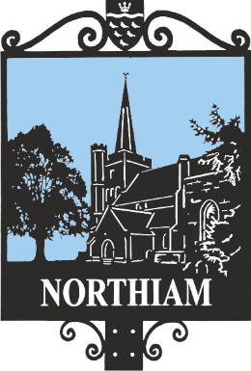

Complaints Procedure

Adopted at the Full Council Meeting held on xxxxx

We are sorry if we have not met your expectations. We strive to provide a high-quality service at all times. If you would like to informally talk through your issue, then please call in, e-mail us at the address below or telephone us on 01797 253990. If this does not resolve your complaint and you would like to make an official complaint, this procedure explains how to do it and provides a timetable for a response and action to your complaint. It also details how appeals are handled.

You can submit details of your formal complaint by:

- Sending a Letter (address shown above)
- Sending an E-mail: (clerk@northiamvillage.co.uk)

You must supply your name, address & either telephone or e-mail address where you can be contacted.

An acknowledgement of receipt of your complaint will be sent within 7 working days and a reply to your complaint within 20 working days.

Step 1

Please contact the member of staff or department who provided the service. Explain what has happened and let them know what you would like the Council to do to put things right. We will try to resolve your complaint at this stage.

Step 2

If you do not accept this response to your complaint in Step 2, you can ask the Parish Clerk to review your complaint. He or she will give you a response within 20 working days.

Step 3

If you are not satisfied with the response from the Parish Clerk, you can ask for your complaint to be reviewed by the Chairman of the Council who may appoint a Panel of up to 3 Councillors to assist if appropriate. The Councillors will not have previously been involved in your complaint. You will have an opportunity to see and comment on the report written by the Parish Clerk about your complaint before it goes to the Panel.

If, the complaint concerns a member of staff, the Chairman or Panel will offer both you and the member of staff an opportunity for interview, prior to making a decision.

If the complaint concerns the Parish Clerk, then the Chairman will manage the process. In the case of the complaint concerning the Parish Clerk, then the complaint should still follow Steps 1 & 2, giving the Parish Clerk two opportunities to resolve the issue before progressing to Step 3. Some disputes may need to be handled outside of our complaints procedure.

For example:
If you wish to disagree with a decision of the Council or one of its committees, where legal proceedings are involved or where you have made a claim for compensation which we refer to our insurers. In this case the Parish Clerk will seek legal advice from either or both KALC and NALC, before advising you of the process.

Staff Areas of Responsibility

Outdoor play areas, & parks. Mrs G Jackson

Finance, All Committees, Council Meetings,
Freedom of information, Data protection. Mrs G Jackson
All other matters.

Address for Complaints or Correspondence:

Northiam Parish Council
Parish Office
Main Street
Northiam, Rye
TN31 6LP

