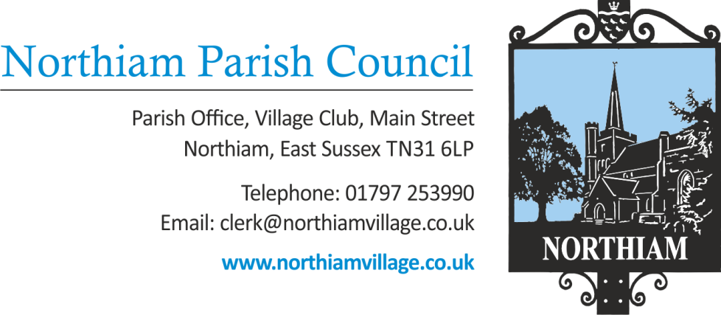

To all members of the Council, you are summoned to attend a Full Council Meeting of the Parish Council on Thursday 14th December 2023 at 19.00.

This meeting will be held at Northiam Village Hall, Main Street, Northiam

Members: Cllr Biggs, Cllr Fairbrass, Cllr Fenton, Cllr Harding, Cllr Luckett, Cllr Russell, Cllr Sargent, Cllr Schlesinger, Cllr Wadie

AGENDA

SIGNED: Nicola Ideson, Parish Clerk Date: 7th December 2023
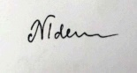
-------------------------------------------------------------------------------------------------------------------------------

 | To receive and accept Apologies for Absence
 | Chairman’s Announcements.

To adjourn the meeting to enable members of the public and Councillors to address the meeting.

This is a concessionary short session and will be limited to 15 minutes. Three minutes per person will be allowed initially and only if time permits will further comments be heard. This is a ‘for information’ session only and no action can be taken upon those items raised.

3 | To receive Declarations of Interest and Lobbying  To receive any declaration by members of personal interests in matters on the agenda, the nature of the interest and whether the member regards the interest as personal, pecuniary or prejudicial under the Code of Members Conduct.
 | Minutes to receive and approve for signature the minutes of the Council meeting held on 9th November 2023. | Appendix A
 | To receive a report from the County Councillor. | Appendix B
 | To receive reports from District Councillors. | Appendix C
 | Finance
 | To receive & approve the payment report for November 2023.
 | To consider the draft budget
 | To consider the precept request 24/25 – to increase the precept by 3.25%. For a Band D Council Tax Payer this will be an increase of £3.34 a year.
 | To approve the opening of a Parish Council bank account with HSBC
 | To agree additional signatories for the Barclays bank account
 | To agree expenditure for IT support requested by the Clerk
 | Expenditure in line with 4.1 of the Financial Regulations
 | No expenditure
 | To consider a quote to legally assess Deeds received from Greymoor Homes Ltd in relation to the Sewer Diversion at the Paddock Development.
 | Governance
 | To agree the meeting dates for next year.
 | To consider forming an independent staffing committee.
 | Outside Spaces
 | To consider the quote received for work required at the Allotments, Village Green and Goddens Gill.
 | To consider forming a Playground working group.
 | To consider a request from the ‘Plotters’ to take over responsibility for paying the allotments water bill directly.
 | To consider a quote received to complete potential safety works to a tree along the footpath between Dixter Road and High Meadow.
 | St Francis Field
 | To consider the quote for a tree safety survey at an Oak tree situated at SFF
 | Updated gate license proposals
 | To consider the status of the current stables planning application due to the change in circumstances.
 | Planning Applications – to consider and agree responses.
RR/2023/2358/P - Coombe Cottage, Ewhurst Lane
Proposal - Demolition of existing bungalow and erection of 2no. 2-bed chalet bungalows and 1no. 4-bed bungalow. Ancillary works to include a new access and drainage system.
RR/2023/2351/P - Fig Tree Cottage, Main Street
Proposal - Single storey infill extension with high level dormer windows.
 | To report any external meetings with representatives of Northiam Parish Council – to allow members to ask any questions and to receive the minutes.
 | To report correspondence
 | Budget Consultation from RDC - RDC are encouraging residents to have their say on the RDC 24/25 budget plans www.rother.gov.uk/budget24. Closes 17th December
 | Consultation on the East Sussex draft Local Transport Plan 4 (LTP4) Closes 25th Feb https://consultation.eastsussex.gov.uk/local-transport-plan-4-2024-2050
 | Reports from Councillors
Second Session for Public Questions
As resolved for inclusion at the July 2023 meeting, a second session for public questions or comments.
 | Resolution to exclude the Press and Public.
In accordance with section 1(2) of the Public Bodies (Admission to meetings) Act 1960 that, because of the confidential and/or sensitive nature of the business to be transacted, (may it be legal, contractual or employment issues), the press and public are instructed to withdraw.
 | Leases
 | Bowls Club Lease.
 | Office Lease

PAYMENT SCHEDULE December 2023

Payee | Budget | Amount Gross | Amount Net | VAT | Method | Description
John O’Conner | Grass contract | £1,082.50 | £902.08 | £180.42 | BACS | Grounds Maintenance - October
NVHT | Admin | £26.00 | £26.00 | - | BACS | Room Hire - October
G H Lowe | Admin | £2,240.00 | £2,240.00 | - | BACS | Locum Clerk (Aug-mid Oct)
N Ideson | Staff Costs | £804.10 |  |  | BACS | Clerk - Oct

